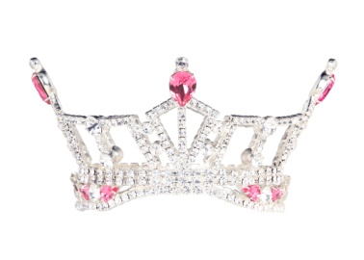
PA’s Outstanding Teen Application for a Local Competition

NAME______________________________________ AGE____ DATE OF BIRTH___________

ADDRESS___________________________________ School Grade_________

____________________________________________ Current GPA_________
Contestant Phone(s) __________________________
Contestant Email ___________________________
School ____________________________________________________
Platform Statement__________________________________________________________________
Talent_________________________
Talent Song ______________________________________________________________________
Mother_____________________________Phone & Email___________________________________
Father______________________________Phone & Email___________________________________
Please fill out the numbers below for statistic purposes.
Children’s Miracle Network Hospitals: Contestant Platform Issue:
Donated Hours: _______ Donated Hours: _______
Money Fundraised: ________ Money Fundraised: ________

Please Send All Paperwork ASAP.
All information must be factual. False information may result in your disqualification from the competition.
You are an official candidate when your Entry Fee is paid and paperwork is received.
All Teen candidates are required to register with CMNH and the Local Competition you are competing in for 2021 year. MPAOTeen Contract will be sent when paperwork is received.
Contracts must be completely filled out with initials on each page and required notarized signatures.
Bring the contract with you to the competition. The Local must have this for you to compete.
Please send your Application, RESUME & CRITICAL ESSAY via email. NO PDF files.
A Signed Application via U.S. Postal Service along with your entry fee & Birth Certificate Copy.
ALL Information Must be typed on all the required entry forms.
Please E-Mail your Headshot PHOTO as a jpeg file ASAP.

Money Order made out to:____________________________________________ for $100.00
Executive Director: _______________________________
Address:________________________________________________
Phone:______________________ Email: ____________________________________
Applications are accepted on a first come first serve basis.
In completing this application, I give permission to the local competition organization to use my photographs and any videos taken for any and all purposes as a candidate of this local organization. Please understand that it is not always possible to receive photo credit. This application may be shared with other Miss Pennsylvania Local Preliminary Competition Execute Directors of the MAO.

Signature of Parent/Guardian: __________________________________________Date: _____________

